FINAL PROJECT



YOGANANDA SCHOOL OF AI, COMPUTERS AND DATA SCIENCES
April, 2026

PROJECT TITLE
HAWK EYE

Submitted by: Submitted to:
Parshav Pathania Prof. Abdullahi
Reg No: GF202219568
BTech CSE CYBERSECURITY

TECHNICAL PROJECT REPORT: HAWK EYE

ADVANCED IMAGE STEGANOGRAPHY WITH SYMMETRIC ENCRYPTION
Author: Parshav Pathania
Technical Stack: Python 3.12, Pillow 10.x, Hashlib (SHA-256), Tkinter Core
Project Scope: Cybersecurity / Data Hiding
GitHub Repository: https://github.com/Parshav141/Hawk-Eye/tree/main

1. EXECUTIVE SUMMAY

Hawk Eye is a specialized security tool designed to achieve Confidentiality and Steganographic Security. Unlike standard encryption, which draws attention to the existence of sensitive data, Hawk Eye utilizes the "Digital Camouflage" of image pixels to hide data. It employs a dual-stage security protocol: a Pre-Processing Encryption Stage using SHA-256 hashed keys, and an Embedding Stage using Bit-Plane manipulation.

PROBLEM STATEMENT

Traditional encryption makes data unreadable, but it does not hide its existence. In scenarios where the mere presence of encrypted data could cause suspicion, steganography provides a "covert channel" for communication.

2. TECHNICAL ARCHITECTURE

2.1 The Cryptographic Engine
The system does not store the user's password. Instead, it uses the password to generate a 32-byte digest via the SHA-256 (Secure Hash Algorithm).
- Key Expansion: This digest ensures that whether the user types "123" or a long sentence, the encryption key is always a robust 256-bit string.
- XOR Stream Cipher: The message is XORed (A⊕B = C$) against this hash. This is mathematically efficient and provides "perfect secrecy" if the key is truly random and as long as the message.

2.2 The LSB Embedding Algorithm
The core logic operates on the Spatial Domain. Digital images are represented as a 3D matrix (Width X Height X Color Channels).

The Mathematical Logic:
For every color byte P(0–255), we isolate the Least Significant Bit.
- Bit Clearing: P_{new} = P AND 254 (This sets the last bit to 0).
- Bit Insertion: P_{final} = P_{new} OR (secret_bit).

Distortion Analysis: The maximum change to a color value is ±1. In a standard 24-bit image, there are 2²⁴ possible colors (over 16.7 million). A change of 1 unit is statistically invisible to the Human Visual System (HVS).

3. IMPLEMENTATION DETAIL
3.1 Data Framing
To prevent the decoder from reading random pixel noise after the message ends, a Sentinel Value (delimiter) is used.
- Delimiter: ###
- Process: The encoder appends ### to the text. The decoder reads bits until it reconstructs the string ###, at which point it terminates the extraction process.
3.2 Graphical User Interface (GUI)
The UI is built using an Event-Driven Architecture:
- Shutter Transition: A custom animation logic that slides a black frame over the screen during state changes to provide a "Cyber-Security" aesthetic.
- Dynamic Error Handling: A dedicated error_label widget is updated in real-time. If the reconstructed message fails the XOR integrity check (Invalid Key), the UI triggers a Red-State notification directly under the password field.

4. SECURITY ANALYSIS & TESTING

4.1 Histogram Consistency
In testing, the image histogram was analyzed before and after embedding. Because XORing data creates high-entropy (randomized) bits, the LSB distribution becomes more uniform, but the overall color peaks remains identical, successfully bypassing casual visual inspection.

4.2 Robustness
- File Integrity: The project mandates PNG (Portable Network Graphics). Since PNG uses DEFLATE (lossless) compression, the bits remain 100% intact.
- Note: The system is sensitive to JPEG compression, which would discard LSB data during its "lossy" quantization phase.

5. REPRODUCIBILITY (The GitHub Workflow)

To ensure the project can be audited or run by external examiners:
- Environment Isolation: A requirements.txt file is provided to define the exact version of the Pillow library required.
- Dependency Installation: pip install Pillow

6. FUTURE ENHANCEMENTS

- Asymmetric Integration: Utilizing RSA keys for the encryption layer.
- Adaptive Steganography: Only hiding bits in "complex" areas of an image (like grass or hair) where detection is even harder.
- Video Steganography: Extending the logic to hide data within the frames of an MP4 file.

IMPLEMENTATION & RESULTS

Phase 1: Encryption & Data Hiding

Step 1: System Launch & Dashboard
This home screen serves as the primary navigation hub, allowing users to toggle between the Hide Message (Encryption) and Reveal Message (Decryption) modules.

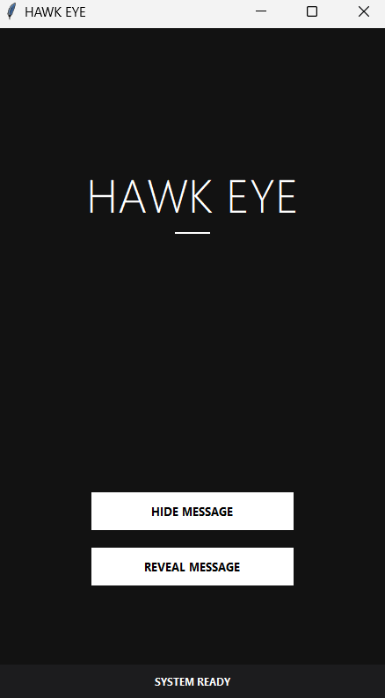

Hide Message: To Encrypt an image
Reveal Message: To Decode an image to reveal the hidden text.

Step 2: Initialization to “Hide” a message:

The process begins at the "ENCRYPT" screen where the user is presented with a clean interface for carrier selection and data input.

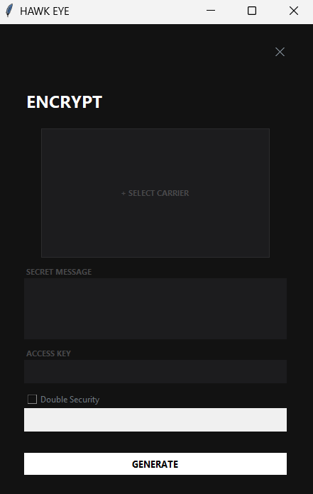

Step 3: Select an Image to Encrypt

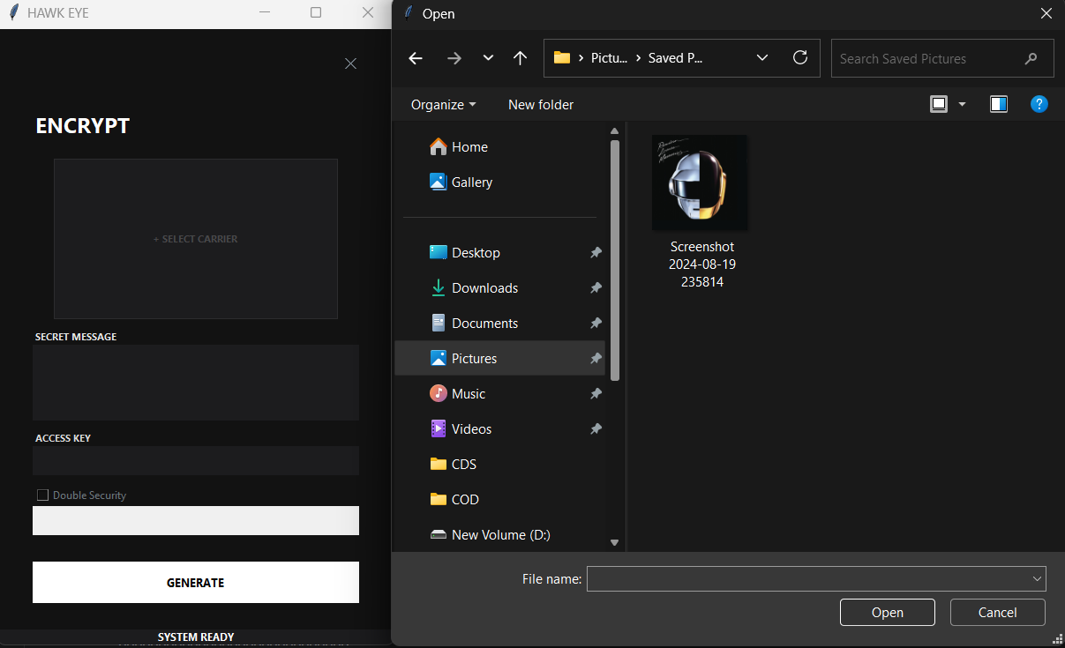
Step 4: Enter your “SECRET” Message

The user encodes the image with a “HIDDEN” message, Like passwords. Then an “Access key” must be added. This key will then be required to “Decode” the Image to get the “Hidden” text.

If the user prefers for an extra layer of security, he/she can add a “Double security” which requires a different key. Which makes the “HIDDEN” message to cipher text for an extra security and to decode the cipher, the other key is required.

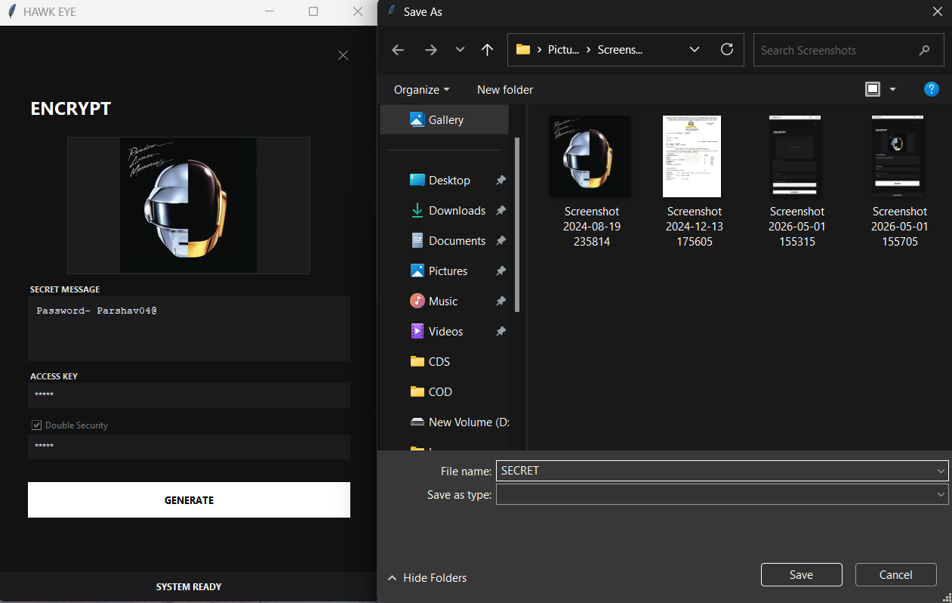

Example:
Secret message: “Password: Parshav04@”
Access Key: 12345
DOUBLE SECURITY: ENABLED
KEY: 12345
CLICK GENERATE

The image will be saved in your computer. And will be normal to a human eye, it can now be used as a wallpaper or shared and no one would have a clue.
Next step to decode the encrypted message.

STEP 5: Decode the Image

Select the image to decode and Enter password to reveal.
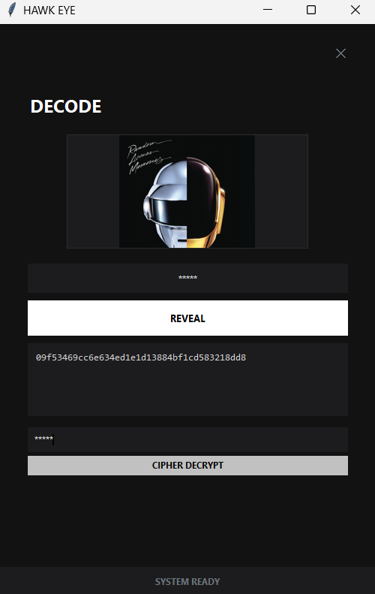

NOTE: After entering the password notice how the actual hidden text is still encrypted, because the user had enabled “Double Security” which made the hidden text to be in cipher when the first key is entered. To actually get the “Hidden” text we need to enter the other key to decrypt to Cipher text.

STEP 6: Cipher Decryption

After entering the other key we get the actual “Hidden text”

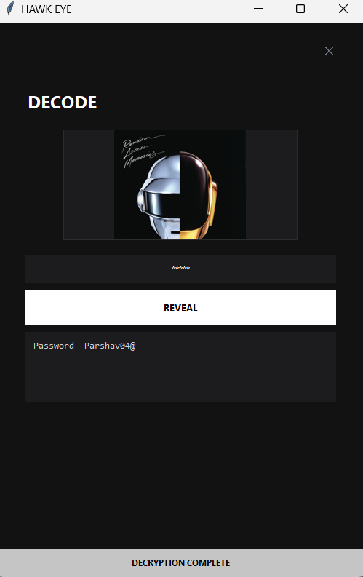

The cipher gets decrypted by the secondary password to get the hidden text.

Secret Message: Password: Parshav04@

CONCLUSION

Hawk Eye successfully demonstrates the synergy between cryptography and steganography. By hosting the project on GitHub with a proper requirements.txt file, the project ensures reproducibility and professional software distribution standards.

APPENDIX: SOURCE CODE

import tkinter as tk
from tkinter import filedialog
from PIL import Image, ImageTk
import hashlib
import time
class HawkEyeTransition:
def __init__(self, root):
self.root = root
self.root.title("HAWK EYE")
self.root.geometry("450x850")
self.root.configure(bg="#121212")

self.img_path = None
self.tk_img = None
self.dual_layer_var = tk.BooleanVar(value=False)

self.main_frame = tk.Frame(root, bg="#121212")
self.main_frame.pack(fill="both", expand=True)

self.status_bar = tk.Label(root, text="SYSTEM READY", font=("Segoe UI", 9, "bold"),
bg="#1c1c1e", fg="#ffffff", pady=10)
self.status_bar.pack(side="bottom", fill="x")

# Initial launch
self.show_home_screen()
#TRANSITION ENGINE
def transition_to(self, screen_func):
"""Animates a fade out, executes the screen change, then fades in."""
def fade_out():
alpha = self.root.attributes("-alpha")
if alpha > 0.1:
alpha -= 0.15
self.root.attributes("-alpha", alpha)
self.root.after(20, fade_out)
else:
self.root.attributes("-alpha", 0)
screen_func() # Change the UI while invisible
fade_in()

def fade_in():
alpha = self.root.attributes("-alpha")
if alpha < 1.0:
alpha += 0.15
self.root.attributes("-alpha", alpha)
self.root.after(20, fade_in)
else:
self.root.attributes("-alpha", 1.0)

fade_out()

#NOTIFICATIONS & UI HELPERS
def notify(self, message, type="info"):
colors = {
"info": ("#1c1c1e", "#6c757d"),
"success": ("#c5c5c5", "#000000"),
"error": ("#bebebe", "#ffffff"),
"warning": ("#adadad", "#000000")
}
bg, fg = colors.get(type, colors["info"])
self.status_bar.config(text=message.upper(), bg=bg, fg=fg)
self.root.after(4000, lambda: self.status_bar.config(text="SYSTEM READY", bg="#1c1c1e", fg="#6c757d"))

def clear_screen(self):
for widget in self.main_frame.winfo_children():
widget.destroy()

#SCREENS (WRAPPED IN TRANSITIONS)

def show_home_screen(self):
self.clear_screen()
tk.Label(self.main_frame, text="HAWK EYE", font=("Segoe UI Light", 40), bg="#121212", fg="#ffffff").pack(pady=(150, 5))
tk.Frame(self.main_frame, width=40, height=2, bg="#ffffff").pack()

btn_container = tk.Frame(self.main_frame, bg="#121212")
btn_container.pack(side="bottom", pady=80)

for text, cmd in [("HIDE MESSAGE", lambda: self.transition_to(self.show_encrypt_screen)),
("REVEAL MESSAGE", lambda: self.transition_to(self.show_decode_screen))]:
btn = tk.Button(btn_container, text=text, command=cmd, font=("Segoe UI", 10, "bold"),
bg="#ffffff", fg="#000000", activebackground="#adb5bd", relief="flat",
width=28, height=2, cursor="hand2", bd=0)
btn.pack(pady=10)

def show_encrypt_screen(self):
self.clear_screen()
nav = tk.Frame(self.main_frame, bg="#121212", pady=20)
nav.pack(fill="x")
tk.Button(nav, text="✕", command=lambda: self.transition_to(self.show_home_screen),
bg="#121212", fg="#6c757d", relief="flat", font=("Arial", 14)).pack(side="right", padx=30)

body = tk.Frame(self.main_frame, bg="#121212", padx=40)
body.pack(fill="both", expand=True)
tk.Label(body, text="ENCRYPT", font=("Segoe UI", 18, "bold"), bg="#121212", fg="white").pack(anchor="w", pady=10)

self.canvas = tk.Canvas(body, width=320, height=180, bg="#1c1c1e", highlightthickness=1, highlightbackground="#2c2c2e")
self.canvas.pack(pady=10)
self.canvas.create_text(160, 90, text="+ SELECT CARRIER", fill="#48484a", font=("Segoe UI", 8, "bold"))
self.canvas.bind("<Button-1>", lambda e: self.load_img())

tk.Label(body, text="SECRET MESSAGE", font=("Segoe UI", 8, "bold"), bg="#121212", fg="#e7e7e7").pack(anchor="w")
self.stego_text = tk.Text(body, height=4, bg="#1c1c1e", fg="white", relief="flat", padx=10, pady=10)
self.stego_text.pack(fill="x", pady=(0, 10))

tk.Label(body, text="ACCESS KEY", font=("Segoe UI", 8, "bold"), bg="#121212", fg="#dbdbdb").pack(anchor="w")
self.pass_image = tk.Entry(body, show="*", bg="#1c1c1e", fg="white", relief="flat", bd=8)
self.pass_image.pack(fill="x", pady=(0, 10))

tk.Checkbutton(body, text="Double Security", variable=self.dual_layer_var, command=self.toggle_dual,
bg="#121212", fg="#6c757d", selectcolor="#121212", activebackground="#121212").pack(anchor="w")

self.pass_cipher = tk.Entry(body, show="*", bg="#1c1c1e", fg="white", relief="flat", bd=8, state="disabled")
self.pass_cipher.pack(fill="x")

tk.Button(body, text="GENERATE", command=self.run_hide, bg="#ffffff", fg="#000000", font=("Segoe UI", 10, "bold"), relief="flat", height=2).pack(fill="x", pady=30)

def show_decode_screen(self):
self.clear_screen()
nav = tk.Frame(self.main_frame, bg="#121212", pady=20)
nav.pack(fill="x")
tk.Button(nav, text="✕", command=lambda: self.transition_to(self.show_home_screen),
bg="#121212", fg="#6c757d", relief="flat", font=("Arial", 14)).pack(side="right", padx=30)

self.body = tk.Frame(self.main_frame, bg="#121212", padx=40)
self.body.pack(fill="both", expand=True)
tk.Label(self.body, text="DECODE", font=("Segoe UI", 18, "bold"), bg="#121212", fg="white").pack(anchor="w", pady=10)

self.canvas = tk.Canvas(self.body, width=320, height=150, bg="#1c1c1e", highlightthickness=1, highlightbackground="#2c2c2e")
self.canvas.pack(pady=10)
self.canvas.create_text(160, 75, text="SELECT IMAGE", fill="#48484a", font=("Segoe UI", 8, "bold"))
self.canvas.bind("<Button-1>", lambda e: self.load_img())

self.pass_image = tk.Entry(self.body, bg="#1c1c1e", fg="#ffffff", relief="flat", font=("Segoe UI", 10), justify="center", bd=10)
self.pass_image.insert(0, "ENTER PASSWORD")
self.pass_image.pack(fill="x", pady=10)
self.pass_image.bind("<FocusIn>", self.clear_placeholder)

tk.Button(self.body, text="REVEAL", command=self.run_extract, bg="#ffffff", fg="#000000", font=("Segoe UI", 10, "bold"), relief="flat", height=2).pack(fill="x")

self.reveal_frame = tk.Frame(self.body, bg="#121212")
self.stego_text = tk.Text(self.reveal_frame, height=5, bg="#1c1c1e", fg="#d2d2d2", relief="flat", font=("Consolas", 10), padx=10, pady=10)
self.stego_text.pack(fill="x", pady=10)

self.cipher_frame = tk.Frame(self.body, bg="#121212")
self.pass_cipher = tk.Entry(self.cipher_frame, show="*", bg="#1c1c1e", fg="white", relief="flat", bd=8)
self.pass_cipher.pack(fill="x", pady=5)
tk.Button(self.cipher_frame, text="CIPHER DECRYPT", command=self.manual_decrypt, bg="#c1c1c1", fg="black", font=("Segoe UI", 9, "bold"), relief="flat").pack(fill="x")

#REMAINING LOGIC (STAYED SAME)
def clear_placeholder(self, event):
if self.pass_image.get() == "ENTER PASSWORD":
self.pass_image.delete(0, "end")
self.pass_image.config(show="*")

def toggle_dual(self):
state = "normal" if self.dual_layer_var.get() else "disabled"
self.pass_cipher.config(state=state)

def load_img(self):
path = filedialog.askopenfilename()
if path:
self.img_path = path
img = Image.open(path).convert("RGB")
img.thumbnail((320, 180))
self.tk_img = ImageTk.PhotoImage(img)
self.canvas.delete("all")
self.canvas.create_image(160, 90, image=self.tk_img)

def xor_crypt(self, data_bytes, key_str):
key = hashlib.sha256(key_str.encode()).digest()
return bytes([data_bytes[i] ^ key[i % len(key)] for i in range(len(data_bytes))])

def run_hide(self):
text, pass1 = self.stego_text.get("1.0", "end-1c"), self.pass_image.get()
if not self.img_path or not text or not pass1:
return self.notify("Missing required fields", "error")

prefix = "P:"
if self.dual_layer_var.get():
pass2 = self.pass_cipher.get()
if not pass2: return self.notify("Cipher key required", "warning")
payload = self.xor_crypt(text.encode(), pass2).hex()
prefix = "C:"
else: payload = text

key1 = hashlib.sha256(pass1.encode()).digest()
final_data = (prefix + payload + "###").encode()
encrypted = bytes([final_data[i] ^ key1[i % len(key1)] for i in range(len(final_data))])
binary = ''.join(format(b, '08b') for b in encrypted)

img = Image.open(self.img_path).convert("RGB")
pixels = list(img.getdata())
new_pix, idx = [], 0
for p in pixels:
p = list(p)
for i in range(3):
if idx < len(binary):
p[i] = (p[i] & ~1) | int(binary[idx])
idx += 1
new_pix.append(tuple(p))

res = Image.new("RGB", img.size)
res.putdata(new_pix)
out = filedialog.asksaveasfilename(defaultextension=".png")
if out:
res.save(out)
self.notify("Image Saved", "success")
self.root.after(1500, lambda: self.transition_to(self.show_home_screen))

def run_extract(self):
pass1 = self.pass_image.get()
if not self.img_path: return self.notify("No image selected", "error")

img = Image.open(self.img_path).convert("RGB")
pixels = list(img.getdata())
key1 = hashlib.sha256(pass1.encode()).digest()

bits, decoded_bytes = "", bytearray()
for p in pixels:
for ch in p:
bits += str(ch & 1)
if len(bits) == 8:
decoded_bytes.append(int(bits, 2) ^ key1[len(decoded_bytes) % len(key1)])
bits = ""
if decoded_bytes.endswith(b"###"):
res = decoded_bytes[:-3].decode(errors="ignore")
prefix, content = res[:2], res[2:]
self.reveal_frame.pack(fill="x")
self.stego_text.delete("1.0", "end")
self.stego_text.insert("1.0", content)
if prefix == "C:":
self.cipher_frame.pack(fill="x")
self.notify("Layer 2 Key Needed", "warning")
else:
self.notify("Data Verified", "success")
return
self.notify("Invalid Key", "error")

def manual_decrypt(self):
try:
data, key = self.stego_text.get("1.0", "end-1c").strip(), self.pass_cipher.get()
final = self.xor_crypt(bytes.fromhex(data), key).decode()
self.stego_text.delete("1.0", "end")
self.stego_text.insert("1.0", final)
self.cipher_frame.pack_forget()
self.notify("Decryption Complete", "success")
except:
self.notify("Key Incorrect", "error")

if __name__ == "__main__":
root = tk.Tk()
# Crisp DPI scaling
try: from ctypes import windll; windll.shcore.SetProcessDpiAwareness(1)
except: pass
app = HawkEyeTransition(root)
root.mainloop()

